Angelica Idoko

Game Engine Scripting

Marc Temkin

October 15, 2020

**Red World (Revised: Game Design Document)**

Genre(s):

• 2D

• Top Down Shooter

Creator(s): Angelica Idoko

Platform(s): Unity

Gameplay:

The game mainly takes place in a fictional town of AdonWell which the protagonist wakes up in. They start off inside of an abandoned law office library which starts off as the tutorial level. Players must navigate through the darkened hallway of the first level of the library using the flashlight to get to the lower floors. The flashlight can be used for areas that are darker and harder to navigate through. Players are able to move using the "WASD" keys on their computer, or laptop and are able to open their inventory using the "I" key, using the Left Mouse to shoot and "E" to interact.

W - Up

A - Left

S - Down

D - Right

I - Inventory

Right Mouse Button - Shoot

E - Interact

Plot:

The plot follows a young woman who wakes up with amnesia to a town riddled with monsters.

Story:

The story follows a 34-year old woman, Julie P. Valentine (Originally named: Jasmín Svobodová), who wakes up in a law library office building, as she makes her way out of the building into the town, she finds that she does not recognize the town, nor have any memory of how she got there. As she looks for help she realizes that the streets are almost abandoned, eventually she comes across a monster eating another civilian in an alleyway which then turns its attention on her and attempts to attack her, but she flees. She looks around to see that everywhere around her monsters are beginning to plague the streets in which some chase her away into a bar with which she meets the current bar owner Adham who tells her that she can stay inside the bar to keep from being killed by the "Civilians" those of which he believes have gone rabid and have started killing each other due to a "virus" that has spread inside the water supply.

* Julie P(orter). Valentine

* Alfie Lam

* Julian Mclellan

* Quinn Proctor

* Ryan Proctor

* Loren Leblanc

* Adham

Inspired Media:

• Hotline Miami & Hotline Miami: Wrong Number

  - This game actually inspired me to explore the more serious themes that being: Violence, and substance abuse. I know that both are very serious topics and should be treated as such. Hotline Miami focuses on how the main protagonist nicknamed as "Jacket" (due to his distinctive letterman jacket) who is sent threatening messages on his answering machine by an unknown caller to eliminate the Russian Mafia who has taken over a large part of the United States. As the game progresses we learn that Jacket uses violence as a way to deal with his trauma of losing his best friend and eventually his girlfriend to the crimes he has committed.

  - Also gameplay wise I wanted to try to do something a little simple, though this might be a bit more challenging based on enemies.

Link(s):

1.) <https://www.youtube.com/watch?v=eWfa2ouQooI>

• Afraid of Monster

  - Afraid of monsters mainly inspired me also because of it themes of substance abuse. At the start of the game you learn the main protagonist David Leatherhoff has been sent a package filled with a mysterious medicine (pain-killers, as the wikia references) by and unknown recipient. The game mostly follows him through his drug induced trip.

Link(s):

1.) <https://www.youtube.com/watch?v=dC0nxK2h_k8>

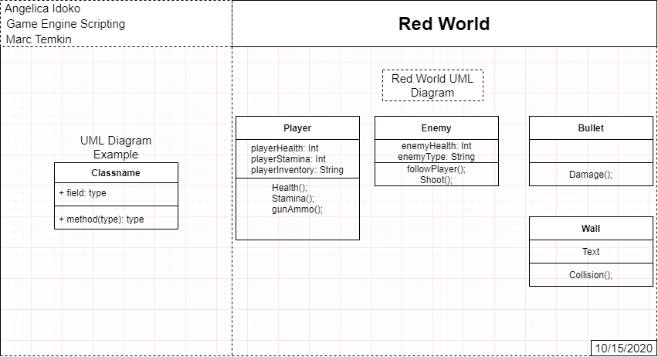

**Concept Art (?)**

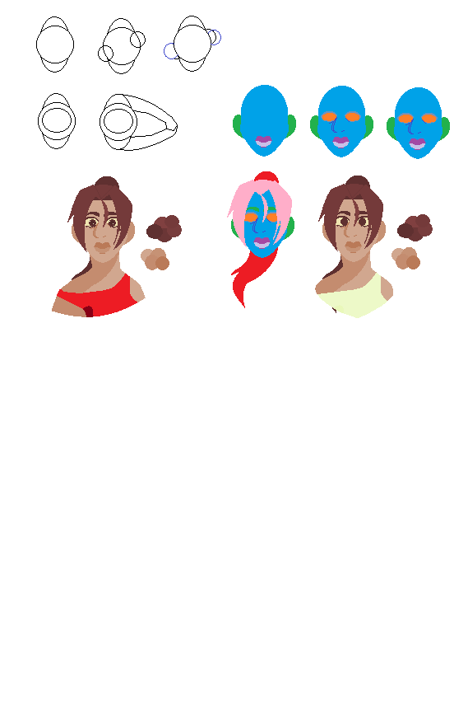

|  |  |  |  |  |  |  |
| --- | --- | --- | --- | --- | --- | --- |
| October | | | | | | |
| 27 | 28 | 29 | 30 | 1 | 2 | 3 |
| 4 | 5 | 6 | 7 | 8 | 9 | 10 |
| 11 | 12 | 13 | 14 | 15 | 16 | 17 |
| 18 | 19 | 20 | 21 | 22 | 23 | 24 |
| 25 | 26 | 27 | 28 | 29 | 30 | 31 |
| 1 | 2 | 3 | 4 | 5 | 6 | 7 |

|  |
| --- |
| **Deadline & Problem Solving:** |
| ***-October 14, 2020-***   * Worked on revising Game Design Document (2-3 Hours)   ***-October 15, 2020-***   * Worked on player movement * I reviewed the code from the last Create with Code project we did (Prototype 2). I tried to use the code from there to test how the player will move but I ran into some problems: Players are met with an invisible wall if they try to move beyond a certain point, and Players don’t collide or hit a wall (But I believe that there is no collision that the wall has to go by. * The thing I have to work on is fixing the player movement and collision with the wall. * I need to fix to the player bullet so players can fire bullets   ***-October 16, 2020-***   * Fix Player Movement * Fix Collision * Fix Bullet * Concept Art (?) * Work on Sprites * Revise Game Doc (Simplify it more(?))   ***-October 17, 2020-***   * Revise Game Doc (Fix any problems with logic) * Work on enemy AI (?) * Work on Three Test Levels   ***-October 18, 2020-***   * Work on 1st Level (Level Design) (Sketches) * Work on Sprites * Work on Enemy AI * Concept Art   ***-October 19, 2020-***  ***-October 20, 2020-***  ***-October 21, 2020-***  ***-October 22, 2020-***  ***-October 23, 2020-***  ***-October 24, 2020-***  ***-October 25, 2020-***  ***-October 26, 2020-***  ***-October 27, 2020-***  ***-October 28, 2020-***  ***-October 29, 2020-***  ***-October 30, 2020-*** |